ELECTRONIC PACE FORM INSTRUCTIONS

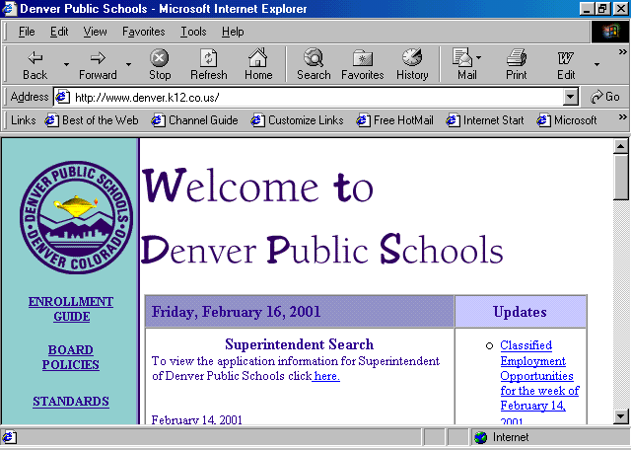
The Lawson pace form is now available to pilot schools only on the DPS web page. In order to access the PACE form you must logon to the Internet DPS web page www.denver.k12.co.us.

Scroll down to DEPARTMENTS on the left-hand side of the page and double click.
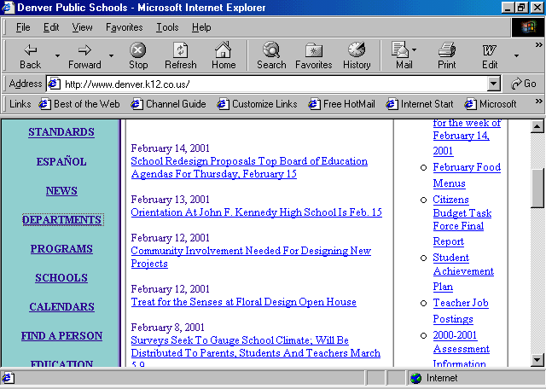

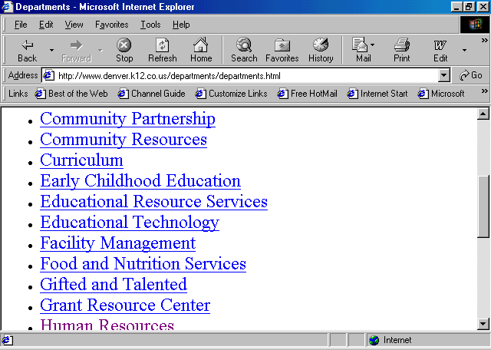Scroll down and double click on HUMAN RESOURCES this will bring you to the Human Resources web page.

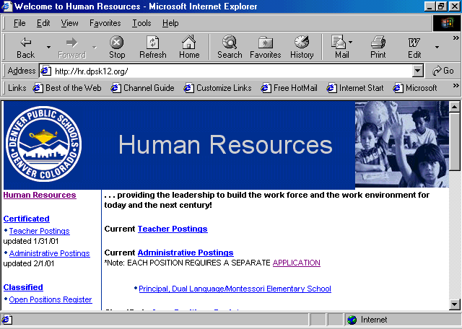

Scroll down to LAWSON, PACE FORM located on the bottom left hand side.

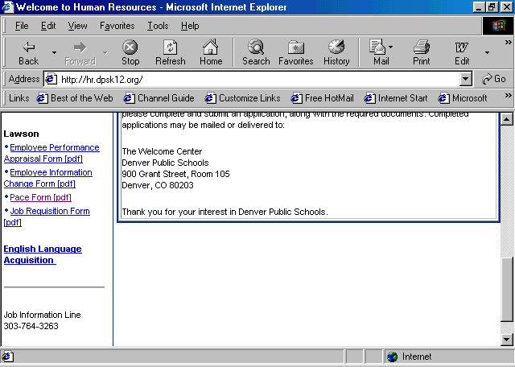
You may now enter your information on the PACE form. Using the tab key will take you to all fields that could be completed.
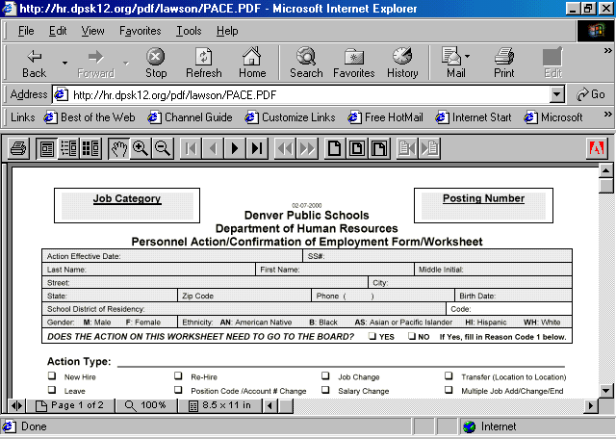

Once you have completed the PACE form you must download the form onto your hard drive.

Note: You will need to create a folder on your hard drive (C drive or your personal directory) to store your PACE forms.

Instructions on downloading a PACE form

Once you have downloaded your PACE form onto your hard drive you are now ready to e-mail your PACE form to Human Resources.

Logon onto Microsoft Outlook click on New

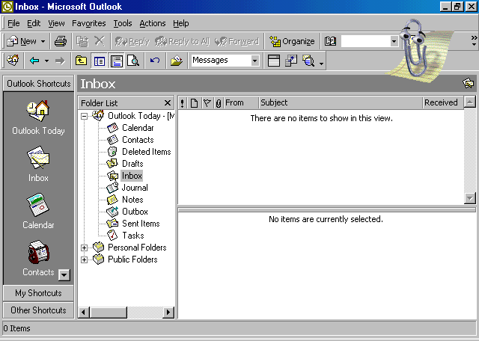
In the To: field enter Hrpace@dpsk12.org hrspecialist_name@dpsk12.org
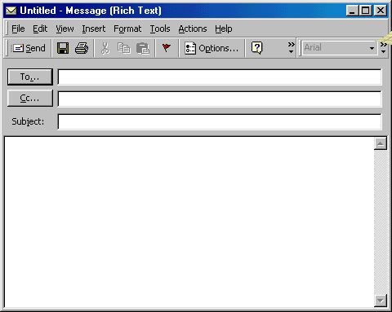

In the Subject field enter Pace form
Address your e-mail to the Personnel Specialist assigned to your school or department.

You are now ready to insert your PACE form click on Insert you will click on the paper clip
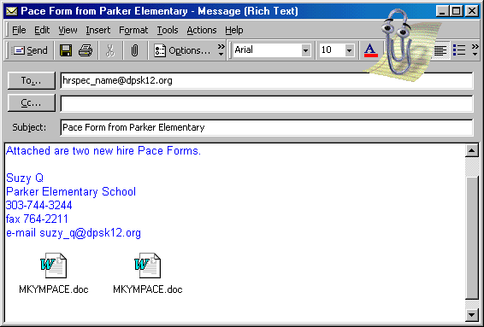

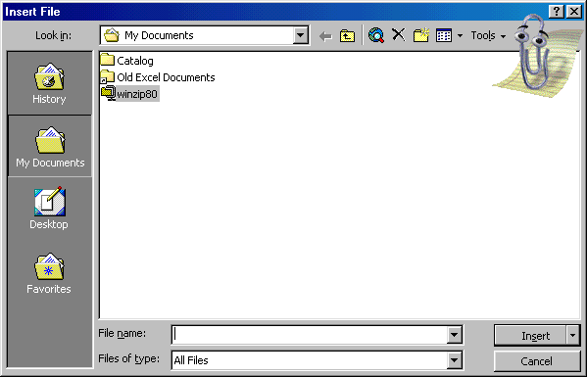

Locate the PACE form by retrieving the folder or directory you saved your PACE form on above. Once you locate the PACE form click on Insert. Your PACE form will now be attached to the e-mail that will be sent to Human Resources.

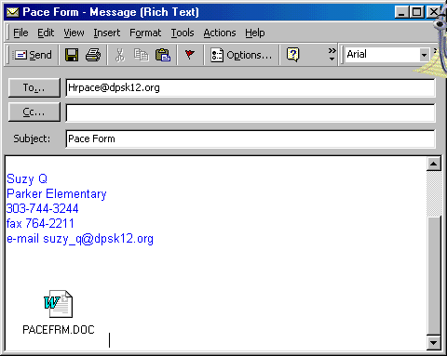
You are now ready to send the PACE form to Human Resources.
Note:
You may send more than one PACE form at a time.

In order to receive confirmation that your e-mail is received by Human Resources please make sure the following information is on your Microsoft Outlook.

On the Tools menu, click Options
Click the Preferences tab,
Click E-mail Options, and then click Tracking Options
Select the Request a delivery receipt for all messages I send check box.
Note: To be notified about a single message, click Options in the message, and then select the Request a delivery receipt for this message check box.

